Table of Contents

Perface 2

Built-in Java Annotation: 2

@Override 2

@SuppressWarnings 3

@Deprecated 5

Use Library The Checker Framwork 7

Introduce 7

Install 7

Config your IDE 8

File Complied 10

Test Source 12

Perface  
  
Annotation are used to provide supplement information about a program. Java Annotation is a tag that represents the metadata (information) for class, interface, methods, fields to indicate some additional information which can be used by java compiler and JVM.  
  
Annotation start with "@", annotation not change action of a compiled program.   
  
Built-in Java Annotations : Override, SuppressWarnings, Deprecated.  
  
Built-in Java Annotations used in others annotations (customize annotation): Target, Retention, Inherited, Documented.

Built-in Java Annotation:

## @Override

Annotation assures that the subclass method is overriding the parent method. if it not show, compile time error occurs. it example bellow show error complier with Overload one function not have in interface. if you want to remove error complie, you should remove @Override in function overload.  
  
  
  
[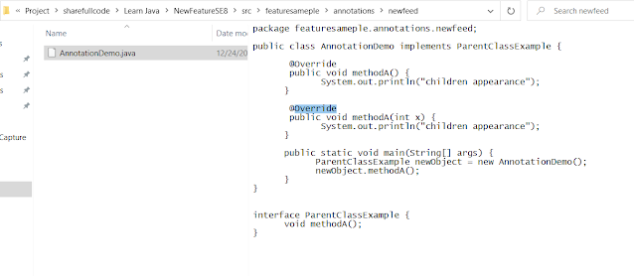](https://www.blogger.com/)

Error during complie Javac,   
  
[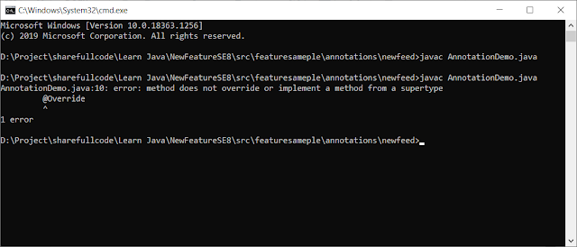](https://www.blogger.com/)

@SuppressWarnings

Annotation: is used to suppress warnings issued by the complier. This type of annotation can be applied to any type of declaration.  
  
This example bellow illustration suppress warning during check javac  
[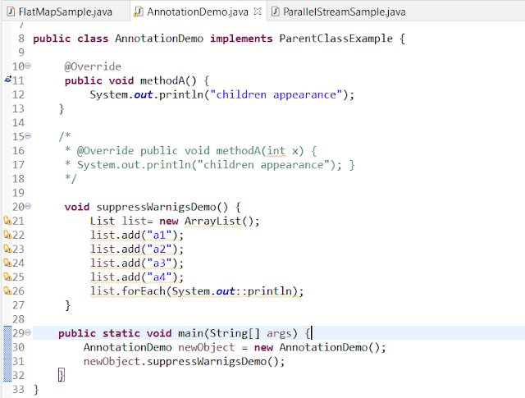](https://www.blogger.com/)

Complie print warning, but complier still success  
  
  
[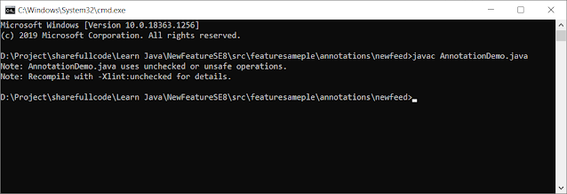](https://www.blogger.com/)  
  
  
Add annotation @SuppressWarning to complie pass not appearance warning  
  
  
[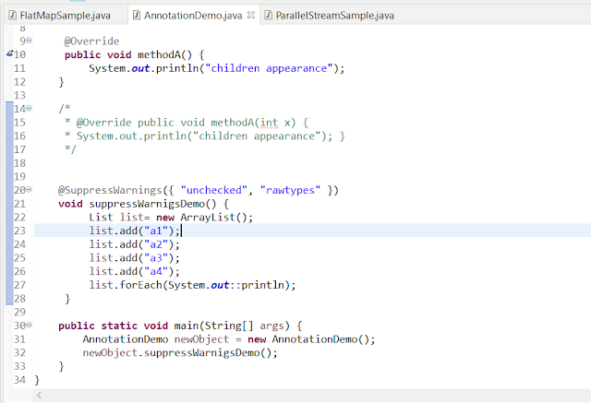](https://www.blogger.com/)

Complie Successful  
  
  
[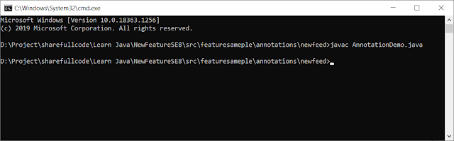](https://www.blogger.com/)

@Deprecated

Annotation marks that this method, field deprecated so complier print warning. in the Future method, filed not use so that now you do not use it.

[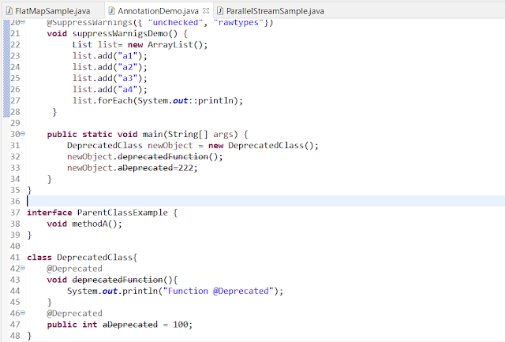](https://www.blogger.com/)

Complie print waring   
  
[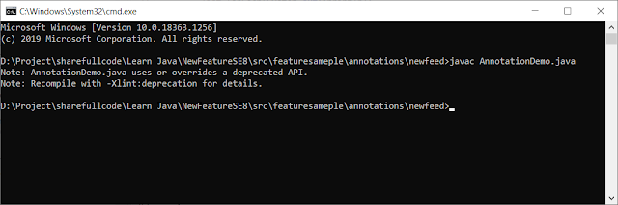](https://www.blogger.com/)  
  
  
To fix not appearance warning to add @SuppressWaring in functions are using Deprecate function. But it waring in source in Eclipse IDE it said "remove @SuppressWarning" it not importain , but the best not use Deprecated for your source.  
  
  
[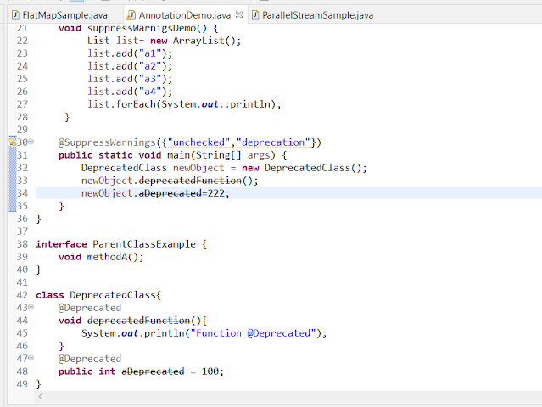](https://www.blogger.com/)  
  
  
Complie not print warning   
  
  
[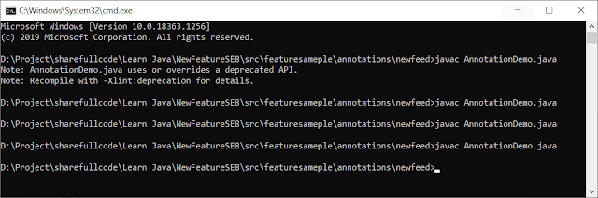](https://www.blogger.com/)

Use Library The Checker Framwork

Introduce :

<https://checkerframework.org> Last Update (1 Dec 2020)  
  
Features : Check null exception, unintended side effects, SQL ịnections, concurrent error, mistaken equality tests.  
  
Summary : The checker framwork help programmer detect and prevent errors in their java programs.  
  
Requiment: JDK 8, JDK 11.

Install  
  
Download file zip : https://checkerframework.org/checker-framework-3.8.0.zip  
Unzip it to create a checker-framwork-3.8.9 directory   
  
  
  
[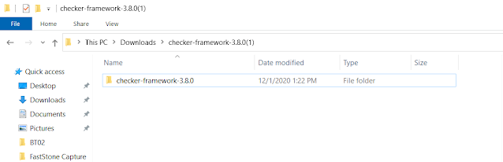](https://www.blogger.com/)  
  
Config your IDE

Build System, or command shell to include the Checker Framawork on the classpath. In this use Eclipse if you other you can ref   
  
[https://checkerframework.org/manual/#external-tools](https://www.blogger.com/)  
  
Add buildPath in project   
  
  
[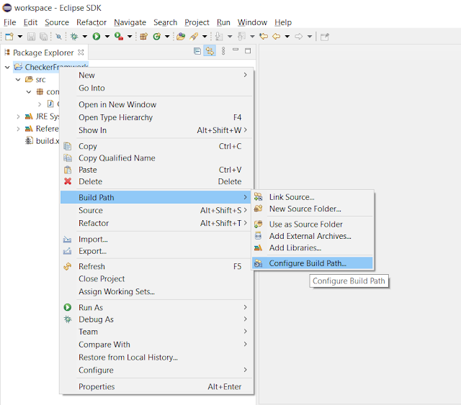](https://www.blogger.com/)

Choice Add Extenal JARs that add File JAR  
  
[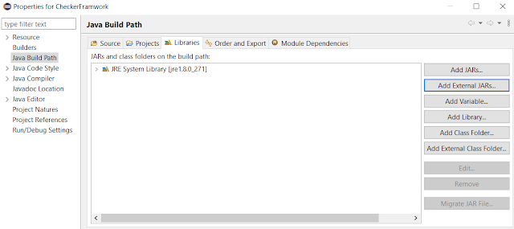](https://www.blogger.com/)  
  
  
  
Ctrl + A and Open all  
  
  
[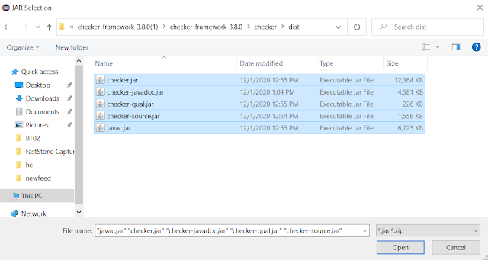](https://www.blogger.com/)

File Complied

Config file Ant That source is complied here i use Ant to complie . I create file build.xml and run it by Ant  
  
  
[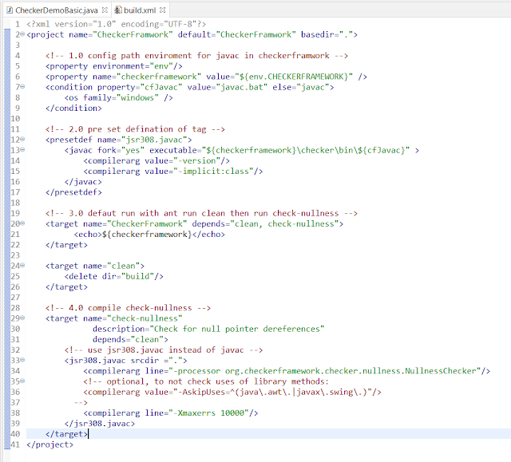](https://www.blogger.com/)

1.0 Set enviroment for variable CHECKERFRAMEWORK in Ant config  
  
Choice file build.xml open External Tools Configurations   
  
[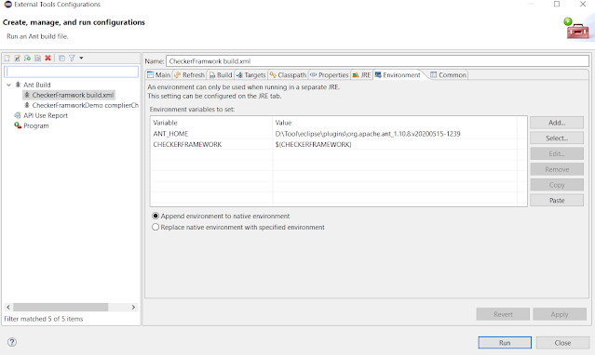](https://www.blogger.com/)  
  
  
New variable CHECKERFRAMEWORK with path fot it directory checker-framwork was unzip before.  
  
  
  
[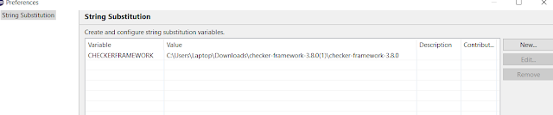](https://www.blogger.com/)

Test Source  
  
Choice build.xml run with ant and complie successful  
  
[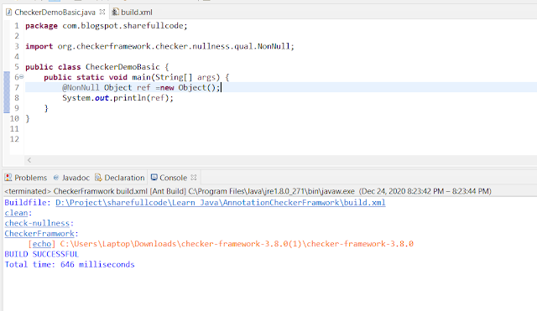](https://www.blogger.com/)  
  
But change object = null complie error  
  
  
[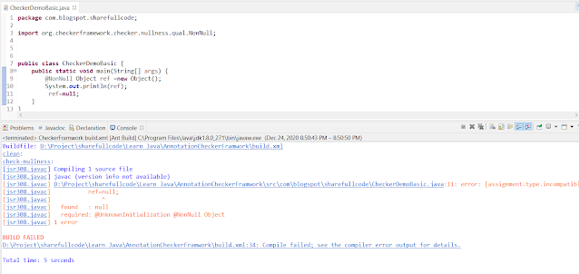](https://www.blogger.com/)

**This section is non commercial mainly sharing and advance knowlage for java.This tutorials has referenced document from the list below if you has complain for license, i will remove all from internet. Thank you all everything.**

https://www.javatpoint.com/java-annotation  
https://www.geeksforgeeks.org/annotations-in-java/